**SQL –ELECTRIC VEHCILES PROJECT**

**Tool Used – MS SQL Server**

1. **Total Vehicles:**

* SELECT COUNT('VIN(1-10)') AS TOTAL_VEHICLES FROM ELECTRIC_VEHICLE_POPULATION_DAT$

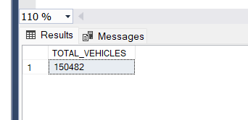

1. **Average Electric Range:**

* SELECT ROUND(AVG(ELECTRIC_RANGE),2) AS AVERAGEELECTRICRANGE FROM ELECTRIC_VEHICLE_POPULATION_DAT$

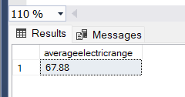

* SELECT TOP 10

MAKE,

COUNT(*) AS TOTALVEHICLES,

RANK() OVER (ORDER BY COUNT(*) DESC) AS RANK

FROM

ELECTRIC_VEHICLE_POPULATION_DAT$

GROUP BY

MAKE

HAVING

MAKE IS NOT NULL

ORDER BY

TOTALVEHICLES DESC

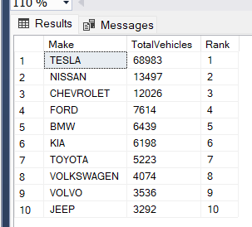

1. **Total BEV Vehicles and % of Total BEV Vehicles:**

* SELECT

COUNT(*) AS TOTALBEV,

CAST(COUNT(*) * 100.0 / (SELECT COUNT(*) FROM ELECTRIC_VEHICLE_POPULATION_DAT$)AS DECIMAL(10,2)) AS PERCENTAGEBEV

FROM

ELECTRIC_VEHICLE_POPULATION_DAT$

WHERE

ELECTRIC_VEHICLE_TYPE = 'BATTERY ELECTRIC VEHICLE (BEV)';

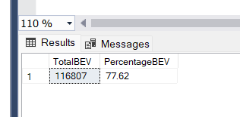

1. **Total PHEV Vehicles and % of Total PHEV Vehicles:**

* SELECT COUNT(*) AS TOTAL_PHEV,

CAST(COUNT(*)*100/(SELECT COUNT(*) FROM ELECTRIC_VEHICLE_POPULATION_DAT$)AS DECIMAL(10,2)) AS PERCENTAGE_PHEV

FROM ELECTRIC_VEHICLE_POPULATION_DAT$ WHERE ELECTRIC_VEHICLE_TYPE='PLUG-IN HYBRID ELECTRIC VEHICLE (PHEV)'

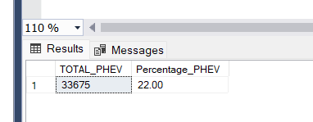

1. **Total Vehicles by Model Year (From 2010 Onwards):**

* SELECT [MODEL YEAR],COUNT(*) AS TOTALVEHCILES FROM ELECTRIC_VEHICLE_POPULATION_DAT$ WHERE [MODEL YEAR]>=2011

GROUP BY [MODEL YEAR] ORDER BY TOTALVEHCILES DESC

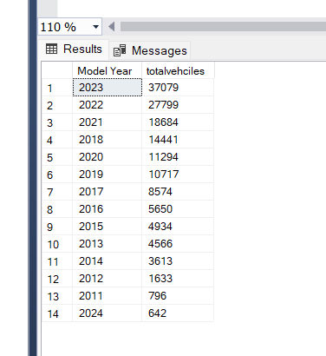

**6 . Top 10 Total Vehicles by Make:**

* SELECT TOP 10 MAKE ,COUNT(*) AS TOTAL_MAKE FROM ELECTRIC_VEHICLE_POPULATION_DAT$

GROUP BY MAKE ORDER BY TOTAL_MAKE DESC

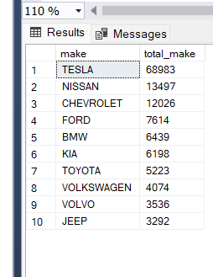

**7. Total Vehicles by CAFV Eligibility:**

* SELECT TOP 10 MAKE

MAKE,

COUNT('CLEAN ALTERNATIVE FUEL VEHICLE ELIGIBLE') AS TOTALS

FROM

ELECTRIC_VEHICLE_POPULATION_DAT$

WHERE

[CLEAN ALTERNATIVE FUEL VEHICLE (CAFV) ELIGIBILITY] = 'CLEAN ALTERNATIVE FUEL VEHICLE ELIGIBLE'

GROUP BY

MAKE ORDER BY TOTALS DESC

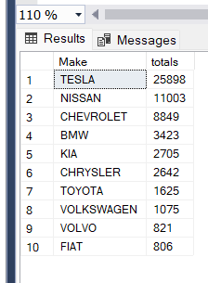

**8. Total Vehicles by Model:**

* SELECT TOP 10 MODEL,COUNT(*)AS TOTALS_MODELS

FROM ELECTRIC_VEHICLE_POPULATION_DAT$ GROUP BY

MODEL

ORDER BY TOTALS_MODELS DESC

